UCLA Library Cataloging & Metadata Center
Website Maintenance Procedures

By Louise Ratliff
April 7, 2006

LIT Contact person: Andy Kohler, x68312
CMDC Webmaster: Louise Ratliff, x58642
CMDC Assistant Webmaster: Raphael Villena, x 65874
CMDC Web Developers: Valerie Bross, Melissa Beck, Claudia Horning, Luiz Mendes

Introduction

The environment for the CMDC (Cataloging & Metadata Center) website consists of a development server, a stage server and a production server.

Web developers create and test their applications on the Development server. When ready to deploy, they copy the application to the Stage area.

Several times a day, an automatic process synchronizes the Production server with the Stage server by copying new files, replacing changed files, and removing deleted files from the Production server, archiving all changes. The synchronization process does not change the Stage area.

Current updating schedule: daily at 2 am, 9 am, 12 noon, 4 pm, and 8 pm.

Web Servers

Development: LIS02B (that’s zero-2-B)

Share for code: lis02b\Development$\unitproj\cataloging
Web server: http://unitdev1.library.ucla.edu/cataloging/

Stage: LIS02B

Share for code: lis02b\Stage$\unitproj\cataloging
Web server: http://unitstage.library.ucla.edu/cataloging/

Production: LIS02

Share for code: none
Web server: http://unitproj1.library.ucla.edu/cataloging/

Preliminary Procedures

Map Network Drives

Map network drives to the Development server and the Stage server. Follow the steps below two times, once for the Development server and once for the Stage server.

- From the Windows Explorer toolbar, select Tools and then select Map Network Drive. Click on the down arrow next to Drive, move the cursor to a drive letter from the list that is displayed, and left-click to select it. (It does not matter which letters you chose, although ones later in the alphabet will be easier to spot in a list of mapped drives, such as X, Y or Z.)

- Click in the white space next to Folder and type the address of the Development server (see step 5 below). Capitalization does not make a difference. The second time you do this, type the address of the Stage server.

- Click to put a check mark in the box labeled Reconnect at logon.

- Click Finish.

- Do this procedure twice. The two server addresses are:

\\lis02b\development$\unitproj\cataloging

\\lis02b\stage$\unitproj\cataloging

- When you have mapped the two drives, you will have a list similar to this:

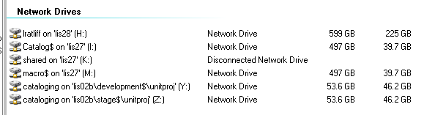

(fig. 1. Example of mapped network drives)
Copy and Save Files

Copy and save all files to the drive you’ve mapped to the Development server. This is the server where you make changes to the website and test them to see if they display correctly. Simply change, add or delete files as you would anywhere; no FTP is required.

You can see this version of the website at: http://unitdev1.library.ucla.edu/cataloging

When everything is working as desired, copy your changes (add, copy or delete existing files) to the drive you’ve mapped to the Stage server. This is the version that will be automatically copied to the Production server for display to the public: http://unitstage.library.ucla.edu/cataloging

To see what is currently in Production, go to http://unitproj1.library.ucla.edu/cataloging/

Files and Templates for the Cataloging & Metadata Center Website

Overview

- When you access the root of the CMDC website on the Development server, you will see a list of folders followed by four individual specialized files: application.cfm, index.cfm, master_template.cfm and navConfig.txt (fig.2).

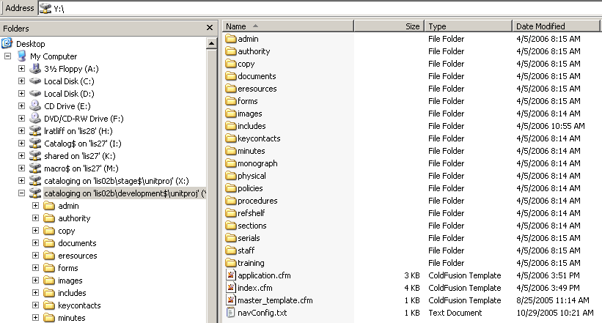

(fig. 2. Root directory folders and files)

3. There are folders for each Section of the Cataloging Center, and for categories of documentation. The web pages for each Section or category should go in the corresponding folder.

4. Each folder must contain an index.cfm file and a navConfig.txt file. Additional folders may be created as needed, but each must contain these two files (about which more later).

3. DO NOT make any changes to the files in the “Includes” folder, which contains master template files.

4. See for example that in the “training” folder there are an index.cfm and a navConfig.txt file (fig.3). There is also a master_template.cfm file which is used as a template to create each page.

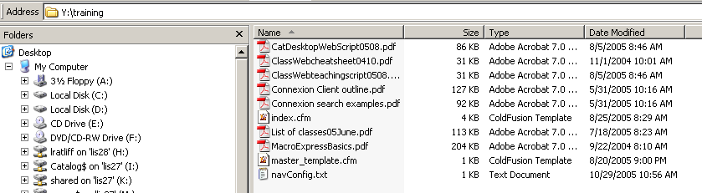

(fig. 3. Example of Section Folder and files for Training Section)

File Types and Site Structure

Every file that will display within the design template (the navigational elements) of the CMDC website must have a “.cfm” extension. These are ColdFusion files.

Other types of files, such as Word or PDF files, may be displayed, but the design templates will not work with them, so the files will display in their native forms (as Word docs, pdf pages, etc.). (A java script is available that will allow such files to open in a separate window, if desired. See later.)

Root Directory Files

The root directory (top level directory) of the CMDC website contains folders and four specialized files which control the navigation and visual design of the web pages. Following is an introduction to each of these specialized files.

application.cfm

One copy of this file exists only in the root directory. It runs a script that displays the Title of a web page and displays the list of that page’s navigation links.

For example, when the web browser displays a page from the “training” subdirectory, the script dynamically displays the sectionTitle “Training and Documentation” (hard coded in the application.cfm file) and the corresponding list of nav links (from the \training\navConfig.txt file) (fig.4).

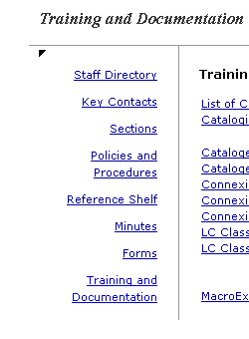
(fig.4) Section title and nav links display for Training and Documentation

Each subdirectory (yes, every folder) of the root directory must be included in the list in the application.cfm file. For ease of use, they are entered in alphabetical order.

For example, here is the entry for the Training and Documentation Section from the application.cfm file:

else if (Find("/training/", PATH_INFO)) {
sectionTitle = "Training and Documentation";
navConfigFile = filePath & 'training\navConfig.txt';
}

When the script runs through the list and finds a matching subdirectory, it displays the hard-coded sectionTitle and the navigation links coded in that subdirectory’s navConfig.txt file.

When the script runs through the list without matching one of the subdirectories, it defaults to the home page Title (“Cataloging and Metadata Center”) and its file list of nav links. This sectionTitle must always be the last in the list. Here it is, the last “else” in the list:

else {
sectionTitle = "Cataloging and Metadata Center";
navConfigFile = filePath & 'navConfig.txt';
}
</cfscript>
index.cfm

The root directory and every subdirectory must have an index.cfm file. The index.cfm file in the root directory is the home page of the CMDC website. This is the main entry page to the site, and is the file to which the the URL http://unitproj1.library.ucla.edu/cataloging/ will default.

master_template.cfm

Use the master_template.cfm file as a template for every page you create for which you want a design template to display. There is a backup copy of this file in most (if not all) of the directories, to be a clean copy to revert to.

To create a new page, simply copy the file and rename it to whatever you want. Files which should display with the template need to have a .cfm extension.

To create content for a new page, open the copied, renamed file in any text editor and start editing. There are some notes in the template that will guide you on what and what not to alter in the template.

navConfig.txt

This file specifies what links to display in the left-hand column of each subdirectory’s page. It consists of a comma-delimited pair of values, each delimited further by a semi-colon that looks something like this:

Home Page,myPage.cfm;
Second Page,secondPage.cfm;
Third Page,thirdPage.cfm ;
Last Page in My Site,exitPage.cfm

The first value in the pair specifies what appears in the link text in the left-column navigation. The second value is the file name.

How to edit the index.cfm files

The root directory and each of the subdirectories has an index.cfm file. There is a top section and a bottom section that may be edited in each index.cfm file which control the page title, display of the date last edited, and the design template for the page.

The main content of the page is inserted between these two control sections.

When you need to create a new index.cfm file for a new subdirectory, make a copy of an existing master_template.cfm file and then modify it. There are comments included in the master_template.cfm file to guide you.

In the top section of each index.cfm file are three areas that may be edited.

cfset pageTitle

Specifies the title that appears in the html <title> tag and in the page subtitle section below the menu bar.

Example:

<cfset pageTitle=”Training and Documentation”>

cfset updatedDt

Specifies the date the page was last updated.
Use the format ‘mm/dd/yyyy’

Example:

<cfset updatedDT = “10/29/2005”>

cfinclude template

Specifies the path to the “includes” folder and the “incBegin.cfm” file in it.
The path may need to be modified, depending on nesting of the subdirectory.

Examples:

Root directory specifies this path:
<cfinclude template=”includes/incBegin.cfm”>

Training subdirectory specifies this path:
<cfinclude template=”../includes/incBegin.cfm”>

In the bottom section of each index.cfm file is one area that may be edited.

cfinclude template

Specifies the path to the “includes” folder and the “incEnd.cfm” file in it.
The path may need to be modified, depending on nesting of the subdirectory.

Examples:

Root directory specifies this path:
<cfinclude template=”includes/incEnd.cfm”>

Training subdirectory specifies this path:
<cfinclude template=”../includes/incEnd.cfm”>
How to edit the navConfig.txt files

Each subdirectory contains a navConfig.txt file which specifies what links to display in the left-column navigation. The left-column navigation will appear on every page; there is no switch to suppress it on some pages and display it on others.

The file consists of a comma-delimited pair of values, each delimited further by a semi-colon.

Here is an example of the navConfig.txt file in the Training subdirectory. Note the paths:

Staff Directory, ../staff/index.cfm;
Key Contacts, ../keycontacts/index.cfm;
Sections, ../sections/index.cfm;
Policies and Procedures, ../policies/index.cfm;
Reference Shelf, ../refshelf/index.cfm;
Minutes, ../minutes/index.cfm;
Forms, ../forms/index.cfm;
Training and Documentation, index.cfm

The first value in each pair of values specifies what appears in the link text in the left-column navigation.

Staff Directory, ../staff/index.cfm;

The second value is the file name, including the path.

Staff Directory, ../staff/index.cfm;

Always separate pairs with a semi-colon, and do not include a semi-colon after the last pair. Hard returns and spaces are fine.

